# Brain Invaders: A P300-controlled game

Brain Invaders is a game controlled by the P300-response of the brain. Based on the classic game Space Invaders, Brain Invaders tasks its players to take out an invasion of aliens. Instead of controlling a cannon however, this is done by focusing on a targeted enemy.

The game consists of multiple levels, each with a specified Alien that the player has to target. Throughout the course of the game, the levels will increase in difficulty by attempting to distract the player from his target. If a player fails to take out the specific target within a given amount of attempts, the level is lost.

The goal of the game is to research the use of distractors in P300 selection. This not only gives insights into the optimization possibilities of a P300-selection program, but also strongly serves for the use of P300-selection in gaming. One of the core features a game should contain is the so called *paradox of control*, a balance between making sure the player of the game feels like he is in control while at the same time having the possibility to fail.[1] The theories of the paradox of control are strongly based around the theories of Flow, as coined by Csikszentmihalyi[2] and help to create more immersive games. With little research done on the game design aspects of Brain-computer games, Brain Invaders hopes to give some first insights into the possibilities of spiking the difficulty of a P300-controlled game.

Brain Invaders features:

* Dynamic levels that allow for complex movement
* Different types of distracting aliens
* A score system to show how well a player performed
* Up to six by six Aliens in the field
* Mixed flashing to increase the P300 response

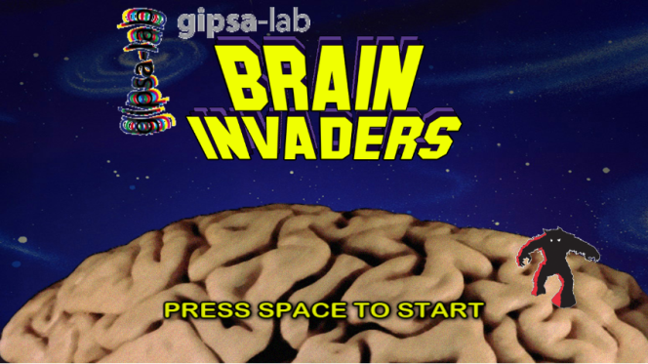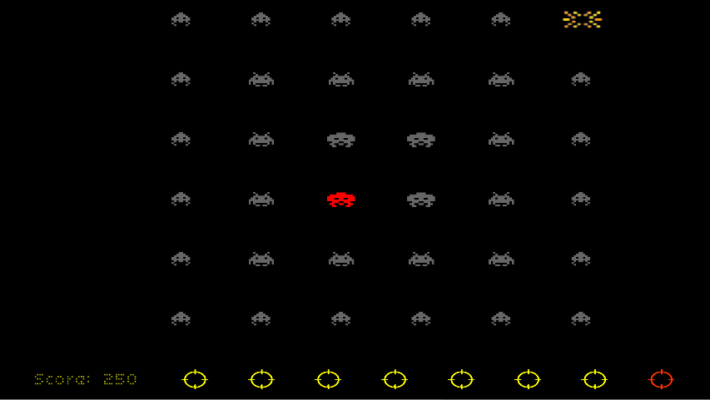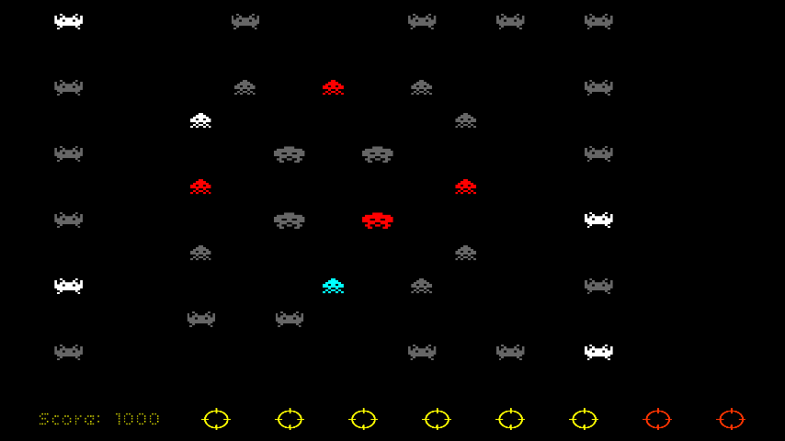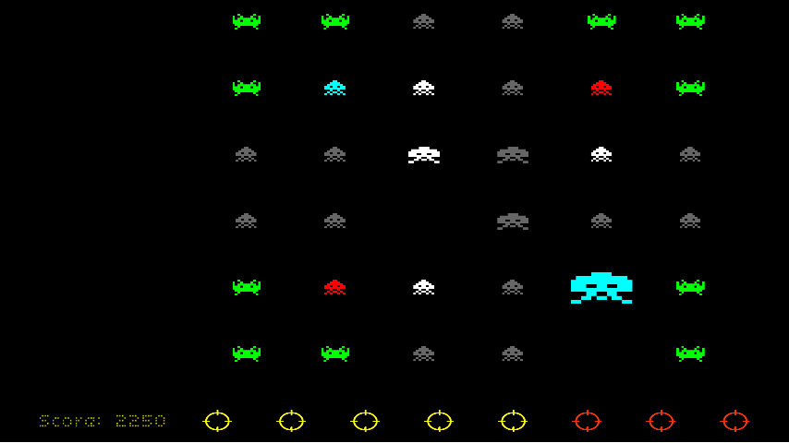*Screenshots of Brain Invaders, depicting different levels of challenge*

Elements still to add to the game are:

* A high score system
* A training mode to calibrate the P300 in-game
* Testing with actual BCI (code should be implemented)

[1] Salen, K. and Zimmerman, E. *Rules of Play: Game Design Fundamentals*. MIT Press, Cambridge, Massachusetts, 2003.

[2] Csikszentmihalyi, M. *Flow: The Psychology of Optimal Experience*. Harper Perennial, London, 1990.